Connect pfSense to Wazuh (Syslog Forwarding)

Part 1: Find the Target (Your Ubuntu IP)
Before pfSense can send the logs, it needs to know exactly where your Ubuntu host is located on the virtual network.
- Open a terminal on your Ubuntu host (not the Windows machine, the actual host machine).
- Type the following command and press Enter: “ip a”
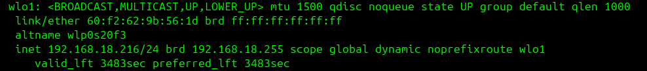
Here my ip address is 192.168.18.216 but pfSense ip is 192.168.204.131
The IP address 192.168.18.216 is your physical home network (likely home Wi-Fi router).
However, because you are using VMware Workstation, VMware creates a hidden virtual network switch inside your Ubuntu machine for the "NAT" connection. This switch is usually called vmnet8.
Even though your physical Ubuntu machine is on the 18.216 network, VMware gives your Ubuntu machine a second, secret IP address on the 204.x network so it can talk to pfSense!
- Type the following command and press Enter to se your secret IP address: “ip a | grep vmnet8 -A 2” (Or just type ip a and scroll through the list until you see vmnet8).
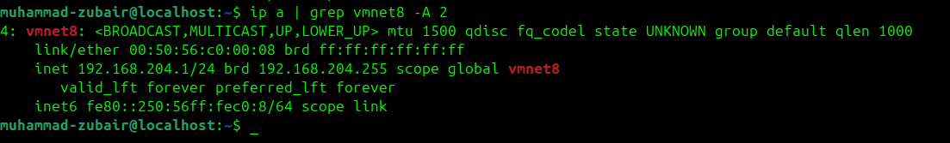
- Look for the line that says inet 192.168.204.1/24
It means our host and pfSense are in the same subnet.

Part 2: Tell pfSense to Send the Logs
Now, we go to the firewall and point it at the Ubuntu machine.
- Go back to your Windows 10 VM and log into the pfSense WebGUI (https://192.168.1.1).
- At the top menu, click Status -> System Logs.
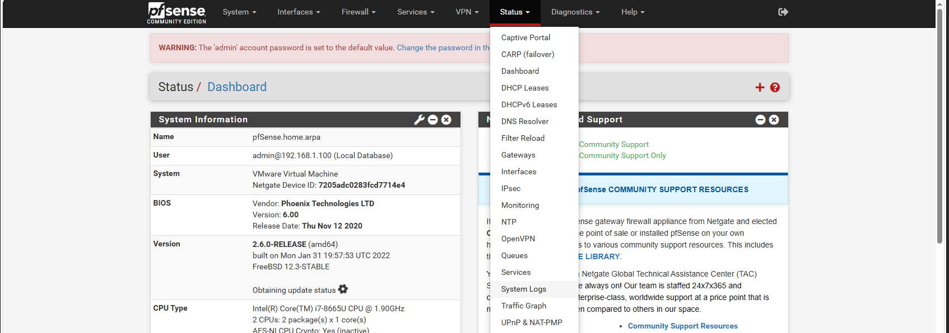
- Click on the Settings tab.
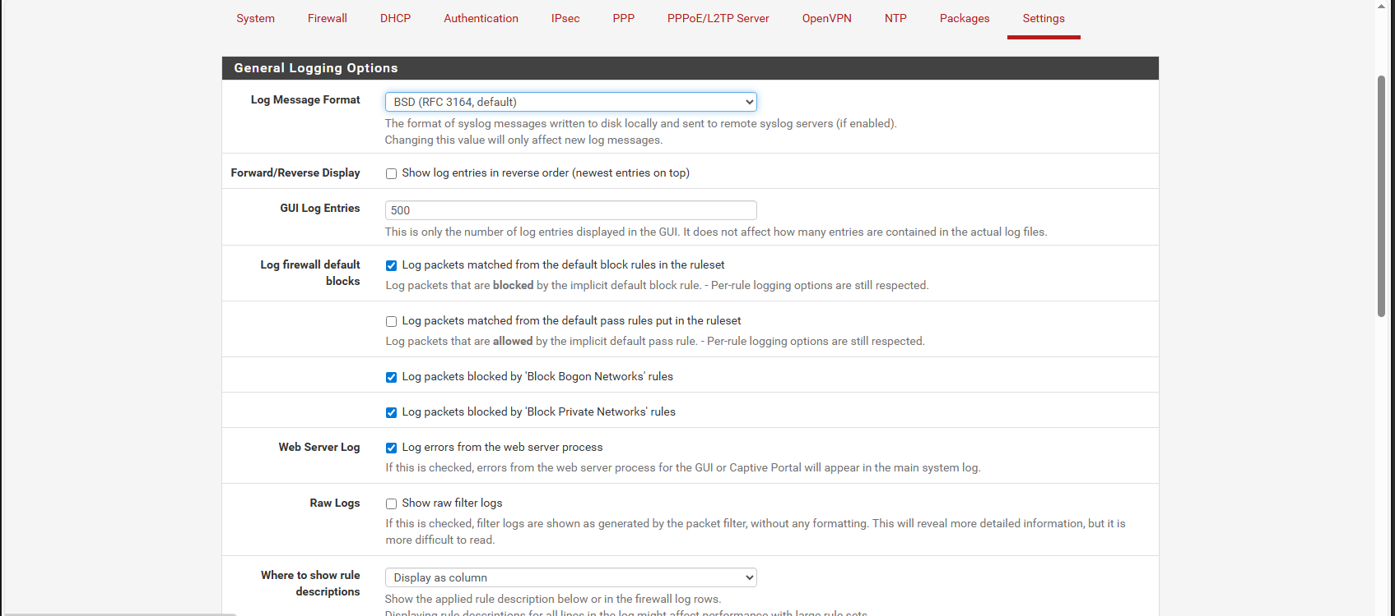
- Scroll all the way down to the Remote Logging Options section.
- Check the box for "Enable Remote Logging".
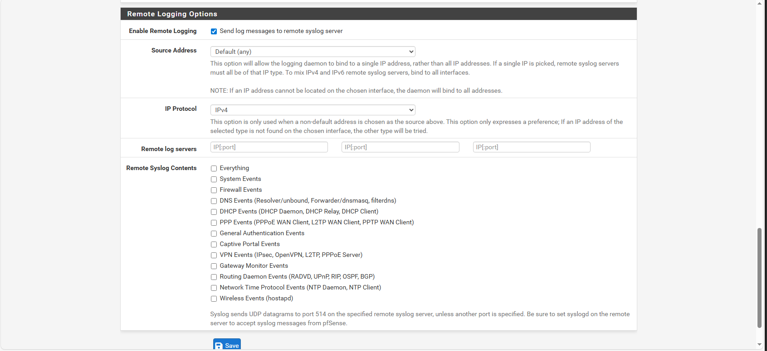
- In the Remote log servers box, type the Ubuntu IP address you found in Part 1, followed by :5140 (For example: 192.168.204.1:5140).
- Under Remote Syslog Contents, check the box for "Firewall Events".
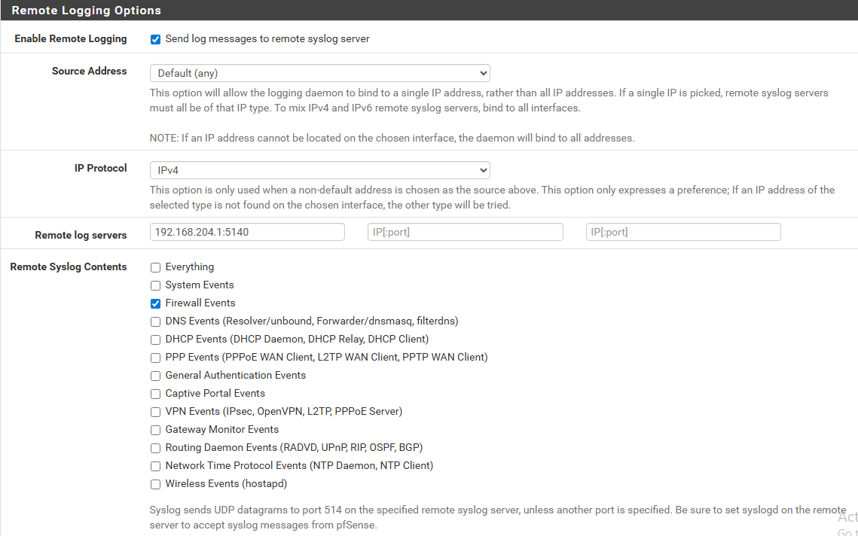
- Scroll to the bottom and click Save.
If you are seeing this message it means your changings are successfully done.

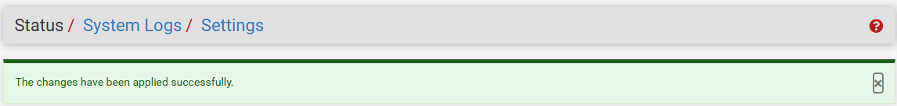

Part 3: Tell Wazuh to Listen
pfSense is now shouting the logs at your Ubuntu machine, but Wazuh's "ears" are turned off by default. We have to turn them on.
- Open your Ubuntu terminal again.
- Edit the Wazuh configuration file:
sudo nano /var/ossec/etc/ossec.conf
- Press Ctrl+w to find the section that looks like <remote> (usually near the top).
- Right below the existing <remote> block, paste this new block to tell Wazuh to listen on port 5140 for Syslog data:
<remote>
<connection>syslog</connection>
<port>5140</port>
<protocol>udp</protocol>
<allowed-ips>192.168.204.0/24</allowed-ips>
</remote>
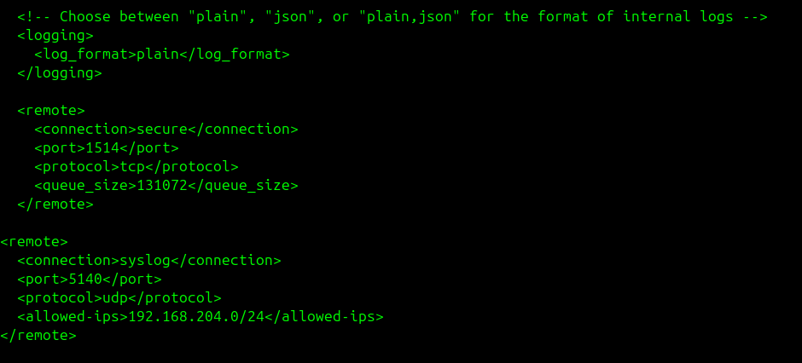
(Note: The <allowed-ips> tells Wazuh to accept logs from any machine on that specific VMware NAT subnet).
- Save the file (Ctrl + O, Enter) and exit (Ctrl + X).
- Restart the Wazuh Manager to apply the ears:
sudo systemctl restart wazuh-manager
If the terminal returns without any error then it means your changings are successfully applied.
Also check to see if the connection is working or not.

Step 1: Open the Ubuntu Firewall
By default, Ubuntu might be blocking incoming traffic on port 5140. Let's make sure the "door" is open.
- Open your Ubuntu Host Terminal.
- Type the following command and press Enter:
sudo ufw allow 5140/udp
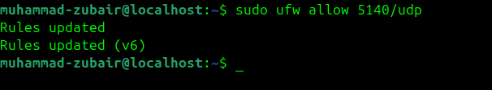

Step 2: The "Packet Capture" Truth Test
Instead of guessing, we will use a tool called tcpdump to physically watch the virtual network cable and see if the pfSense logs are arriving at the Ubuntu machine.
- In the same Ubuntu terminal, run this command:
sudo tcpdump -v -i any udp port 5140
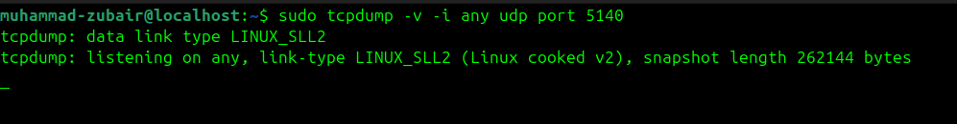
(This command tells Ubuntu to listen to all network interfaces and print any traffic using port 514 to your screen).

Step 3: Make Some Noise!
Right now, tcpdump is listening, but pfSense might be quiet. Let's force pfSense to yell at Wazuh.
- Open a second, new terminal window on your Ubuntu host (leave tcpdump running in the first one).
- Ping the pfSense "WAN" IP address (the 192.168.204.x address) 4 or 5 times:
ping -c 4 192.168.204.131
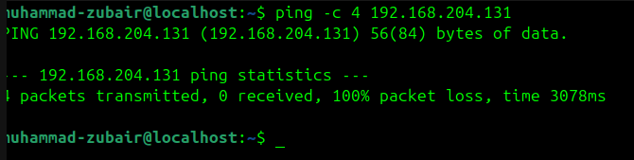
(Because firewalls block outside pings by default, pfSense will drop this traffic and immediately send a log to Wazuh).

The Results
Look back at your first terminal window running tcpdump.
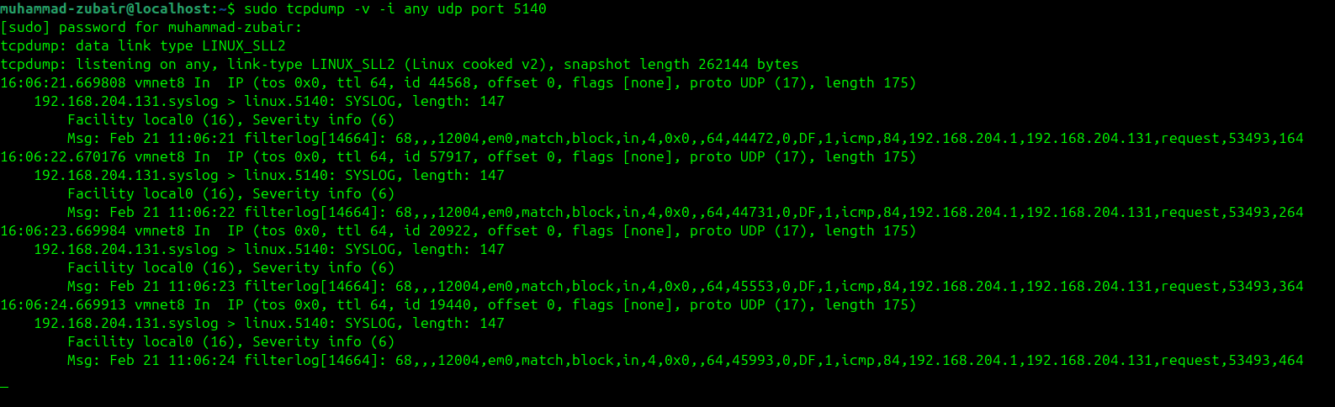
(This is perfect. If your tcpdump is actively listening to the virtual network cable.)

Writing Your First SOC Rule

Step 1: Create the Custom Rule
- Open your first terminal on the Ubuntu host (you can stop tcpdump by pressing Ctrl + C).
- We need to edit Wazuh's local rules file. Type this and press Enter:
sudo nano /var/ossec/etc/rules/local_rules.xml
- Scroll to the very bottom of the file.
- Carefully paste this exact XML block:
<group name="local,pfsense,">
<rule id="100050" level="5">
<match>filterlog</match>
<description>pfSense Firewall Event</description>
</rule>
</group>
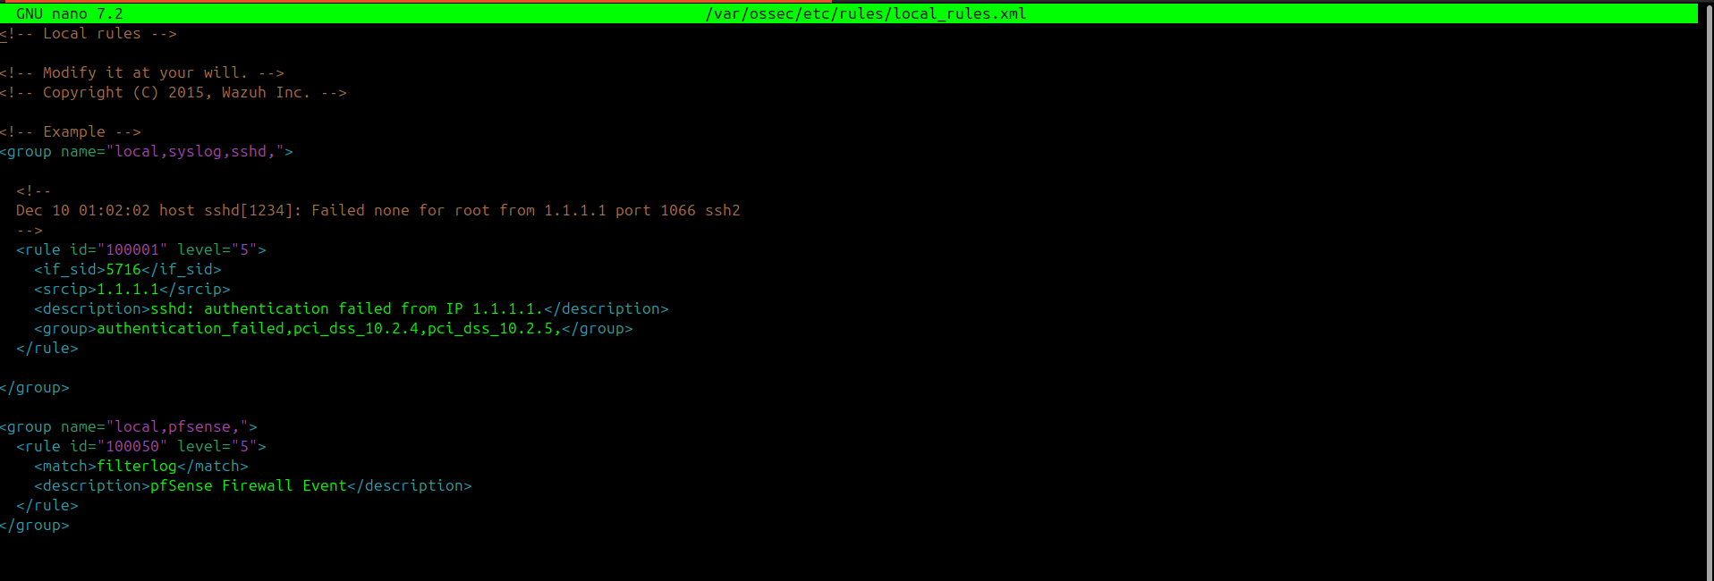
(pfSense tags all of its firewall events as "filterlog". This rule tells Wazuh to look for that tag and immediately generate a Level 5 alert).
- Save the file (Ctrl + O, then press Enter) and exit (Ctrl + X).

Step 2: Restart the Detective
Any time you write a new rule, you must restart Wazuh so it can read it.
- Run this command:
sudo systemctl restart wazuh-manager

Step 3: Make Noise Again!
- Wait about 10 seconds for Wazuh to fully start up.
- Go back to your second terminal and run the exact same ping command to hit the firewall again:
ping -c 4 192.168.204.131

Step 4: Check the Dashboard
- Go to your Wazuh Dashboard in your browser.
- Click Discover.
- Set the time to Last 15 minutes.
- In the search bar, type rule.id: 100050 or pfsense and press Enter.
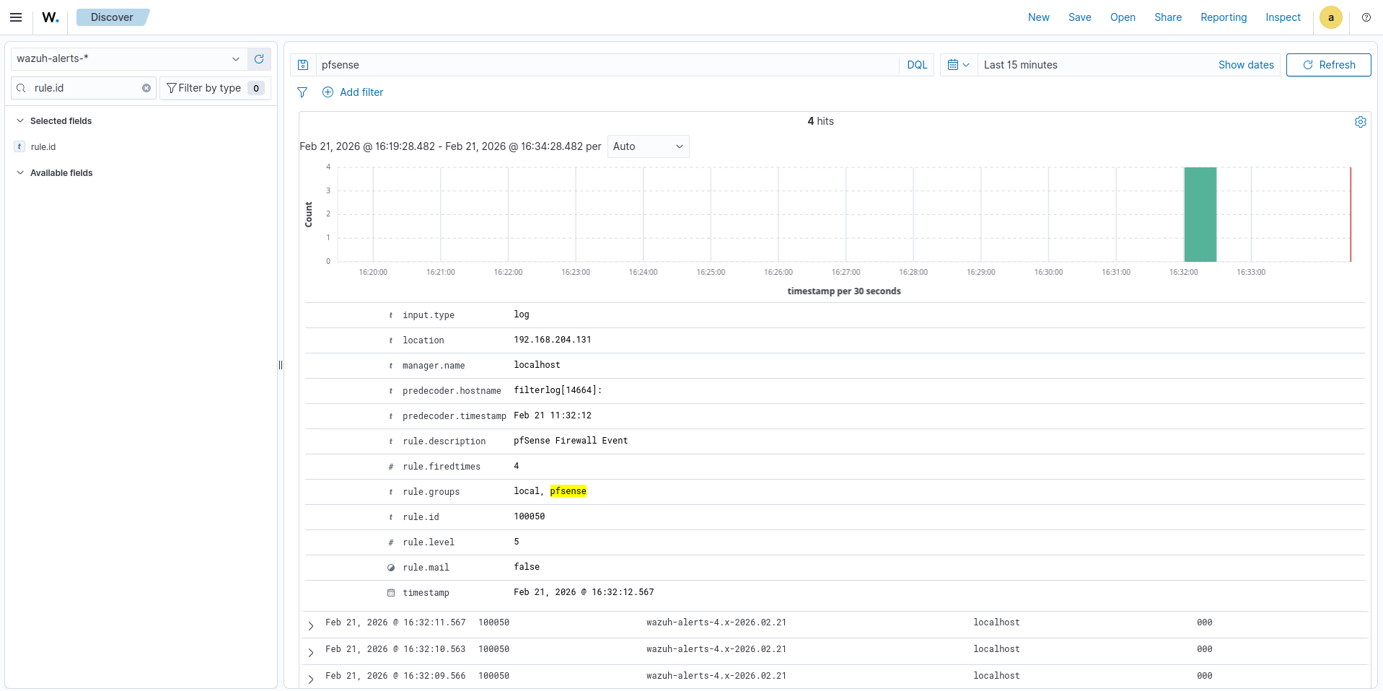

you can see that the pfSense alerts appearing in your dashboard

